COMP 0560: Artificial Intelligence I
Exam I
Spring 1999

Chapter 1: Introduction to AI

- [10pts] What may be some ethical issues related to AI and its use?

- [10pts] In providing a definition for AI, the authors mention that 4 approaches have been followed. List and briefly explain these 4 approaches.

- [5pts] What is the Physical Symbol System Hypothesis? How does this hypothesis relate to “Classical AI”?

COMP 0560: Artificial Intelligence I
Exam I
Spring 1999

Chapter 2: Agents

- [10pts] Explain the difference between goal-based agents and utility-based agents. Is it possible for both of these types of agents to be ideal (Explain)?

- [10pts] Suppose you have an agent that keeps track of your day-to-day schedule. All you do is enter the time that an event is to take place and it will find a way to fit into. If a schedule conflict arises the scheduler will notify you and present you with a number of alternatives. Based on the type of agents that we discussed in class and in the textbook, how would you classify the above agent.
COMP 0560: Artificial Intelligence I
Exam I
Spring 1999

Chapters 3 & 4: Uniformed Search & Heuristic Search

- [10pts] In many search problems it is possible to loop (revisit a state). Explain how it might be possible to modify a tree search algorithm so that it will detect and avoid loops.

- [15pts] Using the Figure below, what order will the nodes be expanded using (a) A*, (b) iterative deepening A*, and (c) beam search.

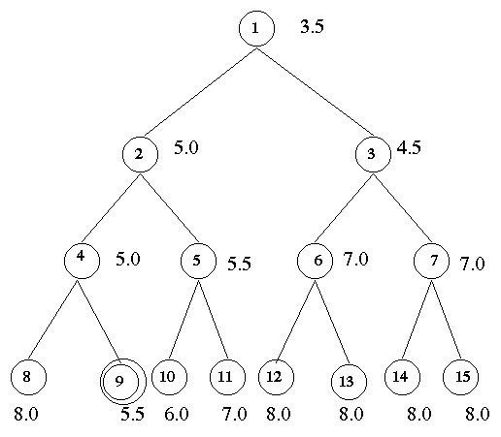

.
COMP 0560: Artificial Intelligence I
Exam I
Spring 1999

- [10pts] The puzzle below consists of 3 black tiles, 3 white tiles, and 1 empty space. A tile can move into the empty space with a cost of 1. A tile can jump over 1 or 2 tiles into the empty space with a cost equal to the number of tiles jumped. The objective is to create a configuration where the black and white tiles alternate. The position of the empty space is not a concern (in the goal state). Formulate this problem into a heuristic search problem. What type of heuristic would you use? Is it admissible?

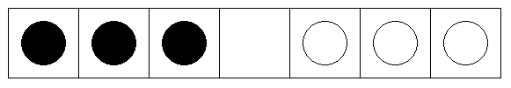

COMP 0560: Artificial Intelligence I
Exam I
Spring 1999

- [15pts] Consider two heuristics H1 and H2. H1 is more informed than H2, and assigns a distinct value to each node. H2 on the other hand assigns N/4 different values to nodes of the search tree. Given that the search tree is very large and that IDA* is going to be used which heuristic would be preferred? Why?
COMP 0560: Artificial Intelligence I
Exam I
Spring 1999

COMP 0560: Artificial Intelligence I
Exam I
Spring 1999

COMP 0560: Artificial Intelligence I
Exam I
Spring 1999

